**Project Repository**

Create a project repository where project details can be entered and viewed / searched at a later time. This should be web enabled and accessible in the local machine via a web browser.

Screen 1

On opening the URL the main navigation screen should come up.

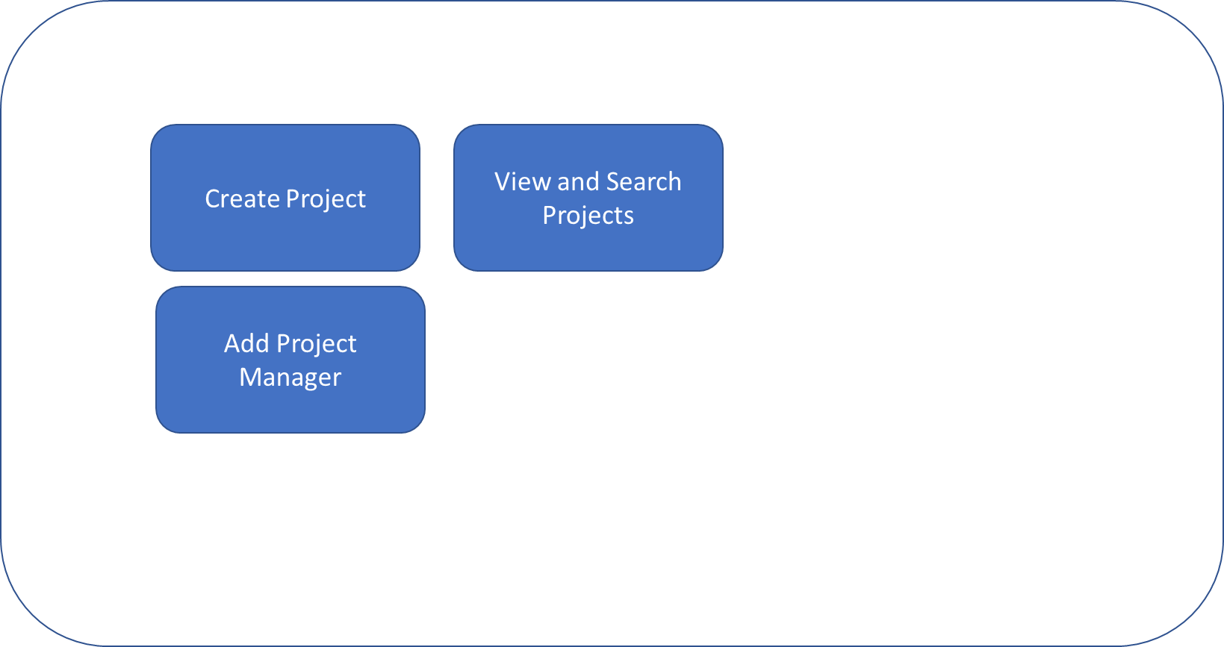

Screen 2

On clicking create project the following page should come up

Project Screen

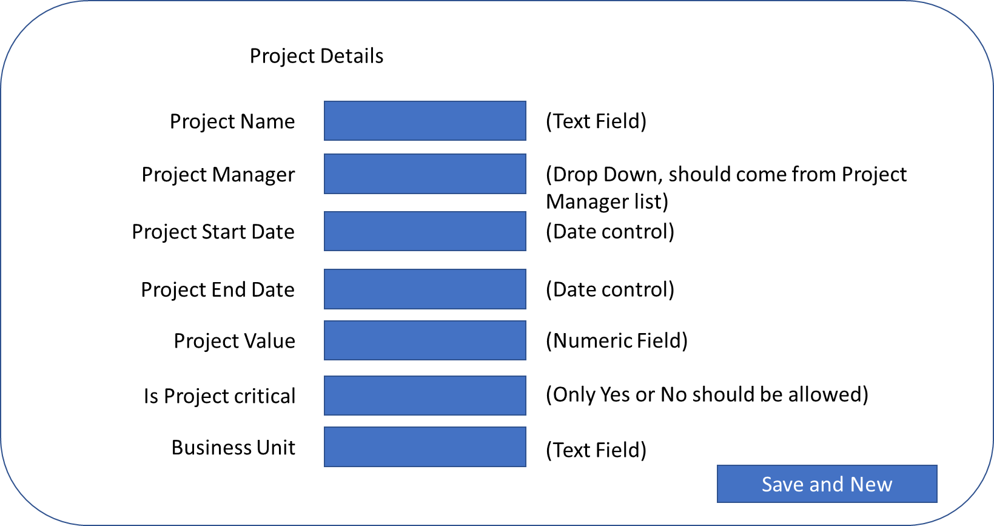

Screen 3

On clicking Add Project Manager the following screen should come up

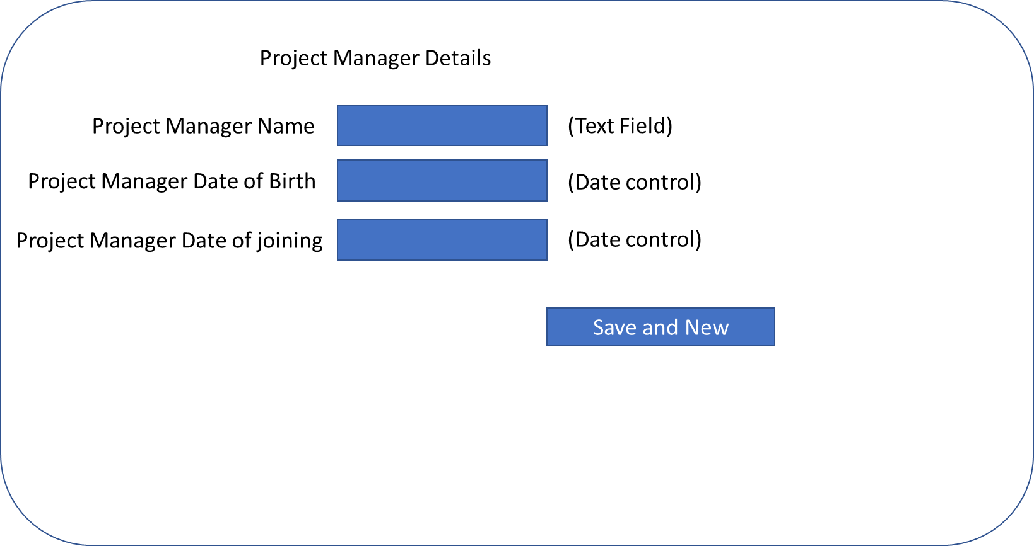

Screen 4

On clicking View and Search Projects the following screen should appear. On opening the screen all projects in the database should be shown. On clicking Ok the control should navigate to Project Details screen with the details of the project. Data should not be editable on this page, it should be read only. User should have ability to sort data based on Project Manager name and Project Value.

